Distributed Git

Centralized Workflow

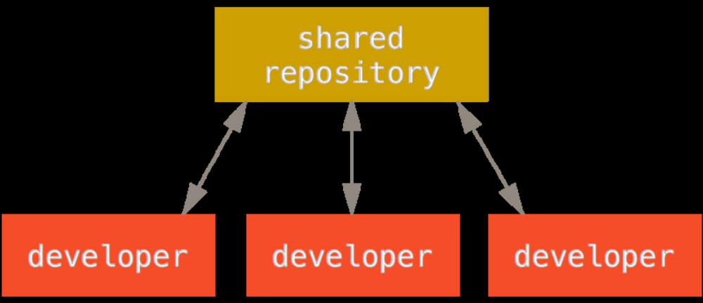

Integration-Manager Workflow

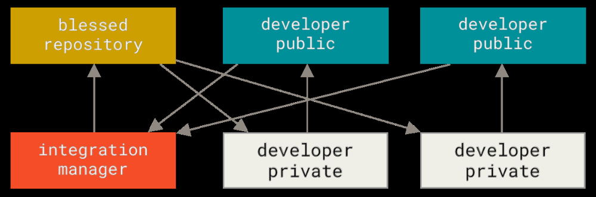

Because Git allows you to have multiple remote repositories, it’s possible to have a workflow where each developer has write access to their own public repository and read access to everyone else’s. To contribute to that project, you create your own public clone of the project and push your changes to it. Then, you can send a request to the maintainer of the main project to pull in your changes. The maintainer can then add your repository as a remote, test your changes locally, merge them into
their branch, and push back to their repository

1. The project maintainer pushes to their public repository.
2. A contributor clones that repository and makes changes.
3. The contributor pushes to their own public copy.
4. The contributor sends the maintainer an email asking them to pull changes.
5. The maintainer adds the contributor’s repository as a remote and merges locally.
6. The maintainer pushes merged changes to the main repository.

Commit Guidelines

- First, your submissions should not contain any whitespace errors. Git provides an easy way to check for this — before you commit, run git diff --check, which identifies possible whitespace errors and lists them for you.

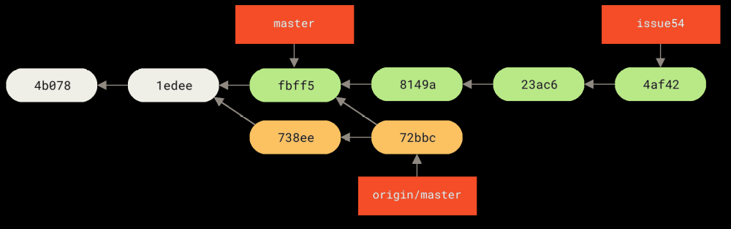

Figure 62. Jessica’s history after fetching John’s changes.

Jessica thinks her topic branch is ready, but she wants to know what part of John’s fetched work she has to merge into her work so that she can push. She runs git log to find out:

$ git log --no-merges issue54..origin/master

commit 738ee872852dfaa9d6634e0dea7a324040193016
Author: John Smith <jsmith@example.com>
Date: Fri May 29 16:01:27 2009 -0700
remove invalid default value

Overall General Sequence

